4.7 Optimization Worksheet

- A farmer wishes to fence off three identical adjoining rectangular pens as in the diagram shown, but she only has 600ft of fencing available. Determine the values for x and y which will maximize the total area enclosed by these three pens.

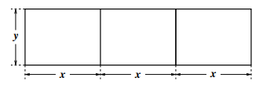

We want to maximize the total area enclosed by the pens.
If A represents the area of the field then . We are also told that .

We need to write A as a function of one variable.

which implies that

Now we can find the critical values of A, and see if any correspond to an absolute maximum.
is never undefined.

We must check to see that corresponds to a maximum area.
75
$$+$$
$$-$$
$$MAX$$

does correspond to a maximum area.

If , then .

- A farmer wishes to enclose a rectangular pen with area next to a road. The fence along the road is to be reinforced and costs $34 per foot. Fencing that costs $16 per foot can be used for the other three sides. What dimensions for the pen will minimize the cost to the farmer? What is the minimum cost?
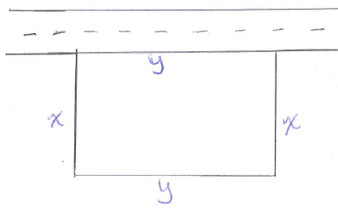
We want to minimize the cost of the fencing.
If C represents the cost of the fencing then . We are also told that .

We need to get the formula for area in terms of 1 variable.
which implies that

Now we can find the critical values of C, and see if any correspond to an absolute minimum.
is undefined when , but this is clearly not a possible value for x in this scenario so we will disregard it.

We must check to see that corresponds to a minimum cost.

$12.5$
$$-$$
$$+$$
$$MIN$$

does correspond to a maximum area.

If , then .

Therefore, the minimum cost is given by: .

- A rectangular storage container with an open top is to have a volume of . The length of its base is twice the width. Material for the base costs $10 per square meter. Material for the sides costs $6 per square meter. Find the cost of materials for the cheapest such container?

We want to minimize the cost of the container.
If C represents the cost of the container then . We are also told that and .

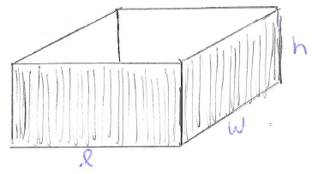
We need to get the formula for C in terms of 1 variable.

which implies that

Now we can find the critical values of C, and see if any correspond to an absolute minimum.
is undefined when , but this is clearly not a possible value for w in this scenario so we disregard it.

We must check to see that corresponds to a minimum cost.
$\sqrt[3]{4.5}$
$$-$$
$$+$$
$$MIN$$

does correspond to a minimum cost.

If , then .

Therefore, the minimum cost is given by: .

- Suppose for . Determine the x-coordinate for the point on this curve which is closest to the origin.

We want to minimize the distance between the origin and curve (remember we can instead minimize ).
If D represents this distance then . We also know that x and y have the relationship.

We need to get the formula for distance squared in terms of 1 variable.

We know that . This implies that
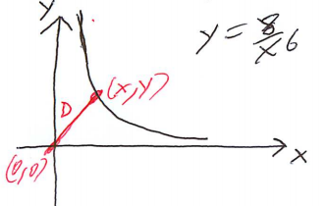

Now we can find the critical values of , and see if any correspond to an absolute minimum.
is undefined when , but this is clearly not a possible value for x in this scenario so we disregard it.

We must check to see that corresponds to a minimum .
$$\sqrt[14]{384}$$
$$-$$
$$+$$
$$MIN$$

does correspond to a minimum and therefore corresponds to a minimum distance.

If , then .

Therefore, the x-coordinate for the point on the curve closest to the origin is .

- The top and bottom margins of a poster are each 6cm and the side margins are 4cm. If the area of the printed material on the poster is fixed at , find the dimensions of the poster with the smallest area.

We want to minimize the total area of the poster.
If A represents the area of the poster then . We are also told that .

We need to get the formula for A in terms of 1 variable.
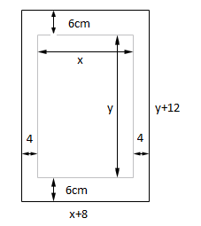
We know that which implies that

Now we can find the critical values of A, and see if any correspond to an absolute minimum.

is undefined when , but this is clearly not a possible value for x in this scenario so we disregard it.

We must check to see that corresponds to a minimum area.
$16$
$$-$$
$$+$$
$$MIN$$

does correspond to a minimum area.

If , then .

Therefore, the dimensions of the poster are 24cm by 36cm.

- Find the area of the largest rectangle that can be inscribed in a semicircle of radius 3. (Hint: sketch your semi-circle using the top half of the circle )

We want to maximize the area of the rectangle.
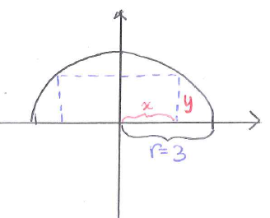
If A represents the area of the rectangle then . We are also know that x and y have the relationship.

We need to get the formula for A in terms of 1 variable.

We know that which implies that .

Now we can find the critical values of A, and see if any correspond to an absolute maximum.

is undefined when , but this is clearly not a possible value for x in this scenario so we disregard it.

We must check to see that corresponds to a minimum area.
$$\frac{3}{\sqrt{2}}$$
$$+$$
$$-$$
$$MAX$$

does correspond to a minimum area.

If , then .

Therefore, the maximum area is .

- A man launches his boat from the bank of a straight river which is 3km wide, and wants to reach a point on the opposite bank 8km downstream as quickly as possible. The man could row straight across the river and then run down the bank 8km to his destination, he could row all the way to his destination, or he could row to some other point on the opposite bank and then run to his destination. If he can row 6km/h and run 8 km/h, where should he land on the opposite bank to reach his destination as soon as possible? What is the minimum time? (assume the speed of the water is negligible)

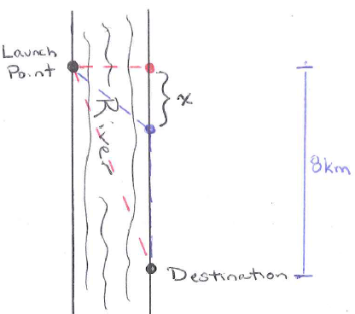
We want to minimize the time the trip takes. Recall the relationship

We first have to compute the distance from the launch point to the landing point on the opposite bank (see diagram below). Therefore, if T represents the time of the trip then

.

Now we can find the critical values of T, and see if any correspond to an absolute minimum.
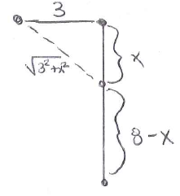
is never undefined.

We must check to see that corresponds to a minimum time.

$\frac{9}{\sqrt{7}}$
$$-$$
$$+$$
$$MIN$$

does correspond to a minimum time.
So he needs to land downstream from his launch point to reach his destination in the shortest time possible. The minimum time is .
- An open box is to be made from a 16-inch by 30-inch piece of cardboard by cutting out squares of equal size from the four corners and bending up the sides. What size should the squares be to obtain a box with the largest volume?

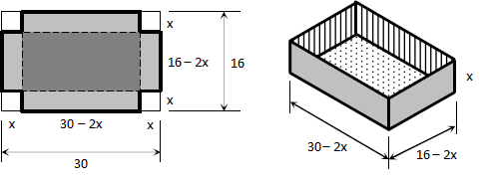
We want to maximize the total volume of the box.
If V represents the volume of the box then .

We calculate that .
Now we can find the critical values of V, and see if any correspond to an absolute maximum.

is never undefined.

We recognize that because that would create dimensions of the box that are impossible. So we will check to see if corresponds to a maximum volume.
$$10/3$$
$$+$$
$$-$$
$$MAX$$

does correspond to a maximum volume.

Therefore, the side length of the square that creates the largest volume is .

